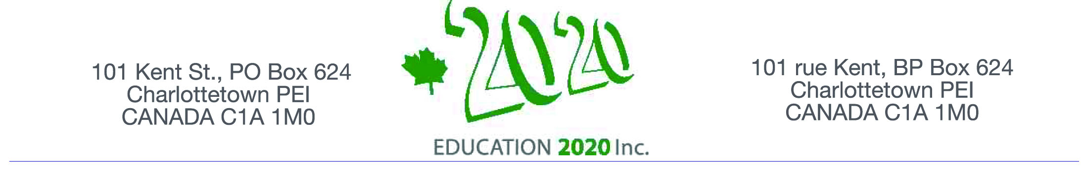

On behalf of Education 20/20 Inc.
I am pleased to invite you to a presentation
on

DACUM: A CANADIAN ACHIEVEMENT

The event is informal and will provide opportunities to meet and talk
to others who share an interest in education.
The session, the second of a series of conversations with Island educators,
will be held at the

Haviland Club from 4-6:00 pm
Thursday, February 12, 2015

DACUM (Developing a Curriculum) is a competency based approach to curriculum development; it was the brainchild of Robert E. Adams, Director of Training at the Nova Scotia NewStart Corporation, Yarmouth, Nova Scotia during the late 1960’s. The presentation and discussion will be led by Dr. Don Glendenning, Lawrence Coffin, Alice Taylor and Gaylene Smith, all with extensive experience in using the model.

I look forward to seeing you on January 12.
Don Glendenning, President

Space is limited so an early RSVP is requested
Email: pei@education2020.ca

Education 20/20 inc. is an independent, broad based, national, not-for-profit education organization located in Charlottetown; its mission is to support a quality education for every Canadian.

